PARADIP PORT TRUST
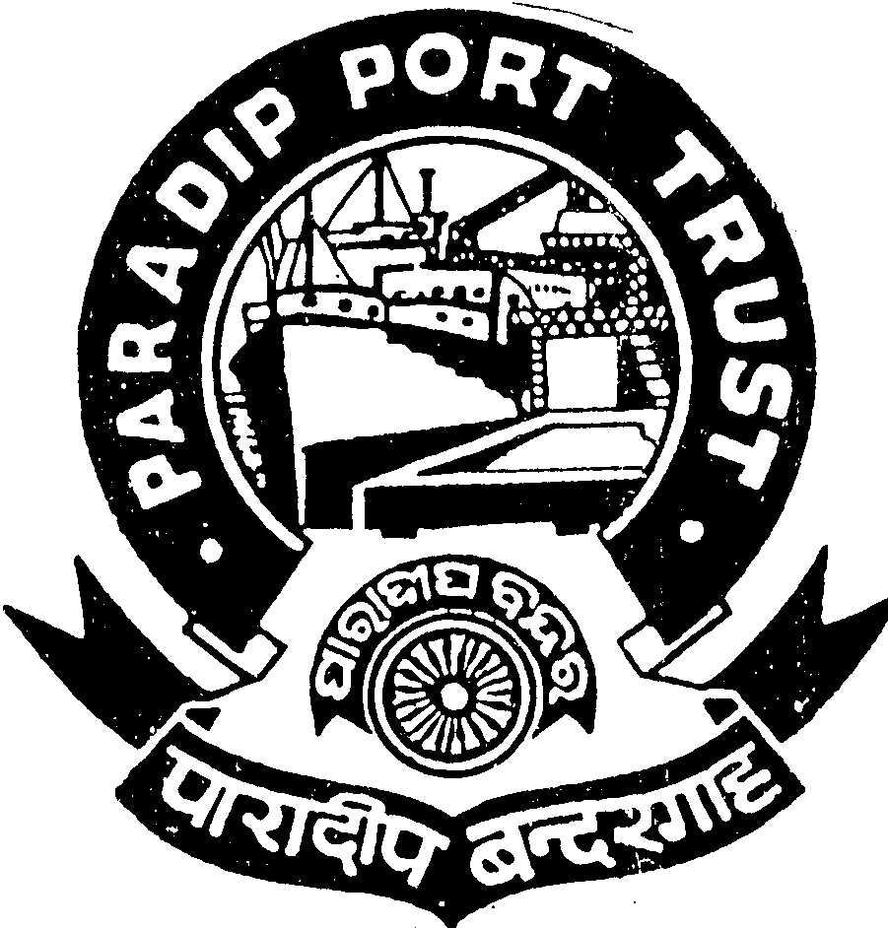
ADMINISTRATIVE DEPARTMENT
AT/PO: PARADIP PORT,
ODISHA – 754 142

No. AD/RSC-I-21/16/2013(Pt.)/3763 Dated, the 5th Sept., 2014

WALK IN INTERVIEW

Paradip Port Trust intends to fill up one post of PILOT in the scale of pay of Rs.32900-58000/- on regular basis as per the terms & conditions given below.

Essential:
(i) Must be holding a certificate of competency as Master of Foreign Going Ship issued by the Ministry of Shipping, Government of India or an equivalent qualification recognized by the Ministry of Shipping, Government of India.
(ii)One year post qualification experience as Master/ Chief Officer of a foreign going ship.

Upper Age Limit : 40 years as on 01.08.2014 (Age relaxable as per Govt. rule).

Pay:

Initial Basic pay + IDA 91.79% of the Basic Pay as on 01.08.2014, which is quarterly revised as per Consumer Price Index along-with Pilotage allowance as admissible. [Pilotage allowances include Actonnage, Length, Cold Move, Night Pilotage etc] and Cafeteria @ 47% of the Basic Pay.

Training: The selected candidates shall have to undergo training for at-least six months and pass the required tests as prescribed in the PPT Regulations.

Other benefits:
Leave Encashment, Free Medical Treatment for self & family, CPF, etc.

Pension:
The contributory pension scheme is applicable.

Accommodation:

Eligible quarters will be provided on concessional rate.

Other Facilities:
Educational facilities up-to Graduation in Science, Arts & Commerce stream in College situated in the Port Township including English Medium (CBSE & ICSE pattern) & Oriya Medium Schools are available.

Please bring original Certificates & testimonials in support of age, qualifications & experience along-with attested copies and two passport size photographs of self. Candidates working in Government/ Semi Government/ Other Major Port/ Public Sector Undertaking should bring “ No Objection” Certificate from the employer.

Admissible TA (to & fro) in 2nd Class Rail/ Bus in shortest route will be reimbursed to SC/ST candidates subject to production of ticket on the date of interview.

Interested candidates may report for interview on 30.09.2014 at 1130 hours at the following address:

SECRETARY,
PARADIP PORT TRUST,
AT/PO: PARADIP PORT,
DIST: JAGATSINGHPUR,
ODISHA – 754 142 S/d-
SECRETARY,
PARADIP PORT TRUST

