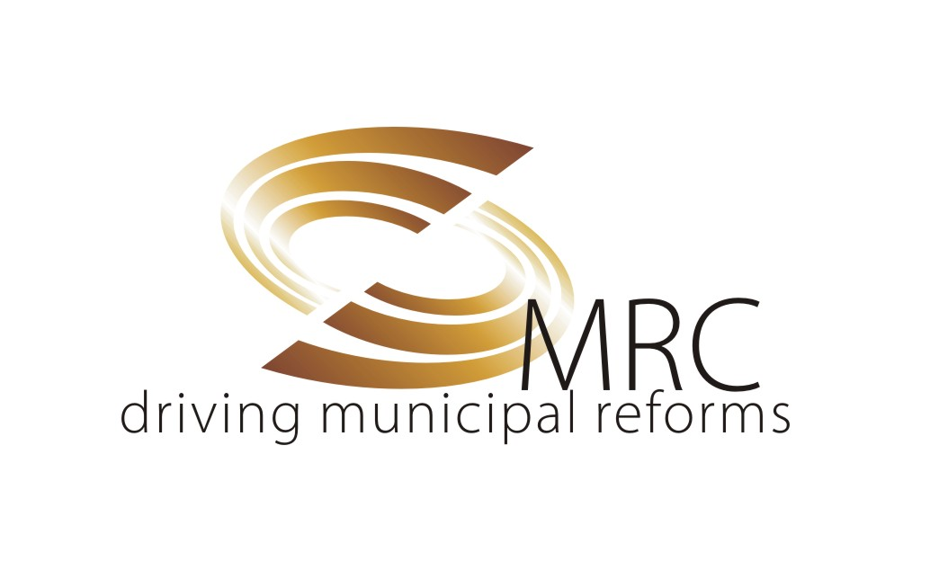 | Municipal Reforms Cell  (Co-ordination and Decision Support System)  6th Floor, 1-4, IT Park,  Rajajinagar Industrial Estate,  Bangalore - 560010

AFFIX YOUR RECENT PASSPORT SIZE PHOTO

APPLICATION FORMAT FOR THE POSTS OF
(Recruitment for CDSS Projects only)
- Software Developer / IT Programmer /
IT Developer / Software Engineer
- Senior Software Developer – Development
- Technical Writer
- Database Administrator

POST APPLIED FOR:

NAME :

DATE OF BIRTH (dd/mm/yy) : AGE AS ON :
(SSLC marks card to be enclosed for age proof)

PERMANENT ADDRESS: ________________________________________________

__________________________________________________________________________

ADDRESS FOR COMMUNICATION: _____________________________________

__________________________________________________________________________

CONTACT NO: PHONE: ___________________ MOBILE: _________________

EMAIL ID: _______________________________________________________________

EDUCATIONAL QUALIFICATIONS: Details of Degree & Master Degree
SL.NO. | QUALIFICATION | SEMESTER/YEAR | YEAR OF PASSING | MAXIMUM MARKS | MARKS OBTAINED | % OF MARKS
1
2
3
4
5
6
7
8
9
10
Total Marks of all Semesters/Years (Individual degree)

EXPERIENCE:

SL. NO. | ORGANISATION | DESIGNATION | HR CONTACT NO. | DURATION |  | TOTAL MONTHS OF EXPERIENCE
 |  |  |  | FROM | TO | GENERAL IN THE FIELD | AS TEAM LEAD

PROJECTS HANDLED:

SL. NO. | ORGANISATION | PROJECT | PERIOD | BRIEF NOTE

REFERENCES :

SL. NO. | NAME | ADDRESS | CONTACT NO.

Note: Sl.No. 1to 4 post should have minimum knowledge of Kannada language.

ACHIEVEMENTS & HONOURS:
1.
2.

Note: Enclose self attested copies of:

- Detailed Resume.
- Marks cards of all semesters.
- Educational qualifications certificates.
- Experience certificates.

SIGNATURE OF THE CANDIDATE

QUALIFICATION AND EXPERIENCE:

- Software Developer / IT Programmer / IT Developer / Software Engineer (03 Post)
Qualification and Experience: First Class and Full time / regular courses of any stream of B.E./B.Tech./M.Tech./MCA and a minimum of 2 years of experience in IT industry in design and development of software applications/products.

Responsibilities:
- Programming and debugging skills and usage of OOAD with ASP.NET framework, C#, MS InfoPath and XML web services.

- Exposure to MSDN, MS Visual Studio and Java (with JSF) is an added advantage.

- Well versed with XML, RDBMSs, HTML and any one type of Operating System – MS Windows / Unix flavour.

- Logical approach in problem solving, attention to details, Analysis and Design skills of IT systems, Good verbal and written communication skills, a good team player.

Consultancy fee Rs. 25,000/- per month.

- Senior Software Developer – Development (1 Post)

Qualification and Experience: First Class and Full time / regular courses of any stream of B.E./B.Tech./M.Tech./MCA and a minimum of 6 – 7 years of experience in IT industry.

- Extensive programming and debugging skills and usage of OOAD with ASP.NET framework, C#, MS InfoPath and XML web services.

- Exposure to MSDN, MS Visual Studio and Java (with JSF) is an added advantage.

- Well versed with XML, RDBMSs, HTML and any one type of Operating System – MS Windows / Unix flavour

- Expertise in understanding and usage of concepts and approaches involving XML, RDBMSs, Hibernate/any ORM tool and any one type of Operating System – MS Windows / Unix flavour. Proficiency in any one of the databases – Oracle/MySQL/Postgres is required.

- Participating in review and finalizing of documents containing the business and functional requirements of systems/applications. Ensuring the technical quality of the deliverables.

- Knowledge of achieving and or maintaining quality standards such as ISO, CMM, BvQI etc. are desirable.

- Logical approach in problem solving, attention to details, Analysis and Design skills of large scale distributed enterprise grade IT systems, Good verbal and written communication skills, a good team player. Able to lead a small team of 8 – 10 resources technically.

Consultancy fee Rs. 30,000/- per month.

- Technical Writer (01 Post)
Qualification and Experience: First Class and Full time / regular courses of any stream of B.E./B.Tech./M.Tech./MCA/ any Bachelor Degree with Science/Electronics/Statistics and Mathematics as the basic subjects, any accredited technical writing training course completion and a minimum of 3 – 4 years of experience in IT industry.

Responsibilities :
- Determine the needs of end users of technical documentation.
- Study product samples and talk with product designers and developers.
- Work with technical staff to make projects easier to use and thus need fewer instructions.
- Organize and write supporting documents for projects.
- Use photographs, drawings, diagrams, animation, and charts that increase users’ understanding.
- Select appropriate medium for message or audience, such as manuals or online videos.
- Standardize content across platforms and media.
- Gather usability feedback from Stake Holders, Designers and End Users.
- Revise documents as new issues arise.

Consultancy fee Rs. 25,000/- per month.

- Database Administrator (01 Post)
Qualification and Experience: First Class and Full time / regular courses of any stream of B.E./B.Tech./M.Tech./MCA and a minimum of 5 – 6 years of experience in IT industry.

Responsibilities :
- Designing and development of database schemas, clusters, load balancing and tuning of database techniques, experience in database management, MySQL, extensive experience in SQL usage, distributed database(s), Object-Oriented / related database setup, management and maintenance including designing backup in any one of the enterprise grade databases (Oracle 10i/11g/12c / Postgres / other). Experience in creating, operating and maintaining of various SQL objects like db, view, table, cursor, trigger etc. and good experience in DDL, DML and DCL is a must. Prior experience in Open source based Database and / or tools is an advantage.

- Designing and developing DBMS solutions for large-scale distributed systems (3 - tier / n – tier and Web based applications) involving large volumes of data, suggest solutions for optimal storage, retrieval, backup and archiving of data.

- Work closely with a team and resolve day-to-day technical issues (related to Database) faced by team members.

- Plan, implement and deploy solutions for various database user accounts like user, administrator, etc and their management.

- Performance tuning of the database for optimal output and keeping in touch with latest technological developments relevant to the work and suggesting cost-effective tools for implementing the same & any other activities which could arise in day-to-day work or on need basis.

- Should have a mindset to work under an environment where tools / applications from Open source are highly encouraged.

- Should be a team player, self starter and able to lead and manage a team of 4-5 members.

Consultancy fee Rs. 30,000/-per month.

