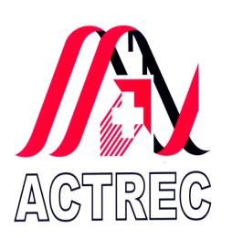 | TATA MEMORIAL CENTRE  ADVANCED CENTRE FOR TREATMENT, RESEARCH AND EDUCATION IN CANCER  Kharghar, Navi Mumbai- 410 210  www.actrec.gov.in  Phone No : 91-22-27405000
No. ACTREC/Advt-68/2013 07.10.2013

WALK- IN – INTERVIEW FOR
Data Entry Operator / Administrative Assistant (Multiskilled)

ESSENTIAL QUALIFICATION: Minimum graduate and having typing speed at 30 w.p.m. in English, 25 w.p.m. in Hindi and fluency in speaking English, Hindi and Marathi. Due preference will be given to the candidates with Shorthand speed @80w.p.m.. Preference will also be given to the candidates who have work experience of 2-3 years as Administrative Assistant/Secretary to Manager/Director and should be well versed with standard data entry and knowledge of SPSS (Statistics Software).

CONSOLIDATED SALARY: Rs. 10,000/- to 15,000/- p.m.

DURATION: 6 months (extendable if required.)

Candidates fulfilling above requirements may walk in for interview on 15.10.2013 at Meeting Room, 3rd Floor, Paymaster Shodhika, ACTREC, Kharghar, Navi Mumbai along with CV and original / attested copies of all certificates and testimonials.

Reporting Time: 10.00 a.m. to 11.00 a.m.

Administrative Officer-II

