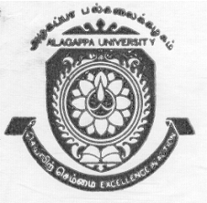 |  | ALAGAPPA UNIVERSITY  (Established by an Act of the Govt. of Tamil Nadu)  (Re-accredited with “A” Grade by NAAC)  KARAIKUDI – 630 003 |  | 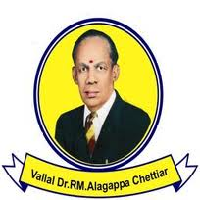
Walk-in Interview
Applications are invited from eligible candidates for Temporary Teaching Assistants in the following disciplines at a consolidated remuneration as per University rules, for the academic year 2013-2014 or till the regular arrangement is made whichever is earlier. Interested candidates can attend the Walk-in Interview which will be held at 10.00 a.m. on 19.07.2013 in the administrative building of Alagappa University, Karaikudi.
Sl. No. | Department |  | No. of posts
1 | English & Foreign Languages |  | 1
2 | Economics and Rural Development |  | 3
3 | Computer Science and Engineering |  | 4
4 | Animal Health and Management |  | 3
5 | Library and Information Science |  | 2
6 | International Business and Commerce |  | 5
7 | Bank Management |  | 2
8 | Corporate Secretaryship |  | 1
No TA/DA will be paid for attending the walk-in interview.
Minimum Qualification required: PG Degree with NET/SLET/SET or Ph.D. (or) M.Phil. with NET/SLET/SET in relevant discipline. The candidates should have at least 55% of Marks at PG level.

The candidates should bring all original certificates along with attested copies of the same at the time of walk-in interview.

09.07.2013 REGISTRAR

