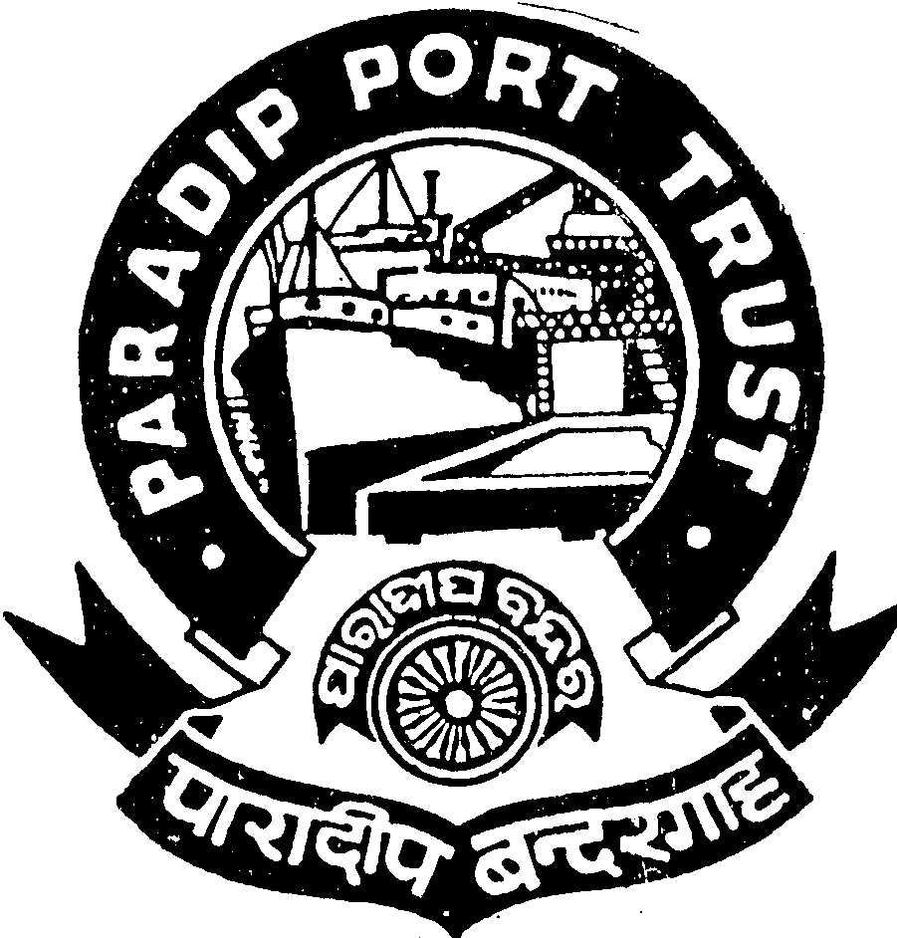

PARADIP PORT TRUST
ADMINISTRATIVE DEPARTMENT
AT/PO: PARADIP PORT,
ODISHA – 754 142

No.AD/RSC-I-24/32/2011/ Dated, the 13th August, 2013
ADVERTISEMENT

Applications are invited from the Indian Nationals for filling up the following post lying vacant under Paradip Port Trust with the following terms & conditions:

01] Dy. Marine Engineer (Scale of Pay Rs.20,600-46500/-) - 01 post:

Qualification:
(i) MOT II Class Motor Certificate issued under Merchant Shipping Act,1958.
(ii) 2 years experience as independent watch keeping Engineer on broad a foreign going ship.

Age: 35 years as on 01.08.2013.

02] The emoluments contains initial Basic Pay + IDA 79.36% of the Basic Pay as on 01.07.2013, which is quarterly revised as per Consumer Price Index,& (iii) cafeteria allowance 46%. (Total emolument will be Rs.46424/- per month besides other allowances.
03] Accomodation :- Unfurnished ‘C’ type quarters on concessional rate shall be provided.

04] Other benefits: Leave Encashment, Free Medical Treatment for self & family, CPF, etc.

05] The contributory pension scheme is applicable.
Educational facilities up-to Graduation in Science, Arts, & Commerce stream in College situated in the Port Township are available including Central School, English & Oriya Medium School.

Application duly signed giving name, date of birth, permanent and present address, religion, caste, qualification starting from HSC with percentage of mark secured and work experience with copies of all self attested certificates along-with two self attested pass-port size photographs should reach the Secretary, Paradip Port Trust, At/Po: Paradip Port, Orissa, Pin: 754142 latest by 16th September 2013. Persons in the employment of Government/Semi-Government/PSU and autonomous body must apply through proper channel or produce a No Objection Certificate from the employer at the time of interview. The application should be type written. Incomplete or late application will summarily be rejected.

Sd/-
Secretary(I/C),
Paradip Port Trust

Copy to: The Secretary, All Major Port Trusts, for wide circulation amongst the eligible officers of your Ports

