PARADIP PORT TRUST
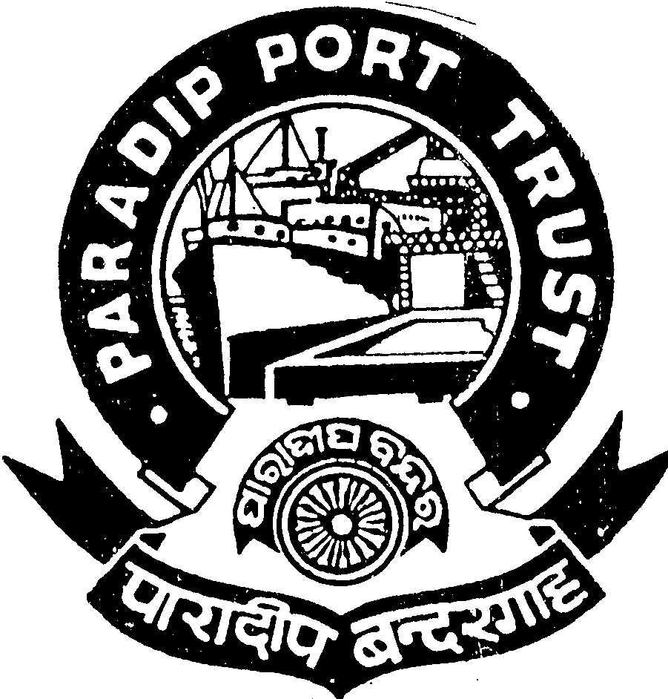
ADMINISTRATIVE DEPARTMENT
AT/PO: PARADIP PORT,
ODISHA – 754 142

No.AD/RSC-III/21/67/2012/2883 Dated, the 17th July, 2013

ADVERTISEMENT

SPECIAL RECRUITMENT DRIVE

Applications are invited from the Indian National for filling up of one post of SENIOR SIGNALMAN (Reserved for SC under Special Recruitment Drive) as per the terms & conditions given below:

SENIOR SIGNALMAN (Scale of PayRs. 9400-22000/-)

Qualification: (1) Passed +2 from a recognized Institution, (2) Possess RTG Operator Certificate issued by Government of India, (3) Completed a course on computer familiarization & able to enter data in computer, (4) preference will be given to candidates having familiarization on GMDSS & Inmarsat terminals & having completed ARPA & RNRP course as per the requirement of STCW 95 regulations from a DG (Shipping) approved organization. (Candidates do not possess the RTG Operator Certificates issued by Govt. of India need not apply for the above post).

Age : Not exceeding 35 years as on 01.07.2013 (Age relaxable as per Govt. rule).

Pay:

Initial Basic pay + IDA i.e 79.36 % of the Basic Pay. The IDA is quarterly revised as per Consumer Price Index. Initial pay will be more than Rs. 17,000/- PM including allowances as admissible.

Other benefits:
Leave Encashment, Leave Travel Concession, Free Medical Treatment for self & family, CPF, etc.

Pension:
The contributory pension scheme is applicable.

Other Facilities:
Educational facilities up-to Graduation in Science, Arts & Commerce stream in College situated in the Port Township are available including English Medium (CBSE & ICSE pattern) & Oriya Medium Schools.

Application duly signed giving name, date of birth, permanent and present address, religion, caste, qualification starting from HSC with percentage of mark secured, caste certificate in the prescribed format and work experience with copies of all certificates along-with two pass-port size photographs should reach the Secretary, Paradip Port Trust, At/Po: Paradip Port, Odisha, Pin : 754 142 latest by 20th August 2013 . Persons in the employment of Government/Semi-Government/PSU and autonomous body must apply through proper channel or produce a ‘No Objection’ Certificate from the employer at the time of interview. The application should be type written. Incomplete or late application will summarily be rejected.

Admissible TA (to & fro) in 2nd Class Rail/ Bus in shortest route will be reimbursed to SC candidates subject to production of ticket on the date of interview.

S/d-
Secretary(I/C),
Paradip Port Trust

