PARADIP PORT TRUST
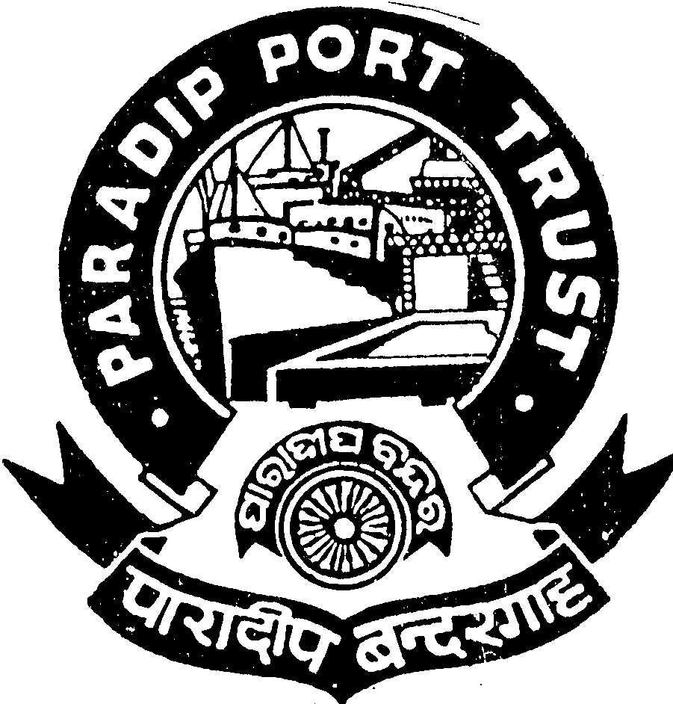
ADMINISTRATIVE DEPARTMENT
AT/PO: PARADIP PORT,
ODISHA – 754 142

No.AD/RSC-I-21-74/2011/2834 Dated, the 11th July ,2013

ADVERTISEMENT

Paradip Port Trust, an ISO-9001:2008 certified organization, intends to recruit 03 (three) posts of Deputy Chief Medical Officers (Specialist) such as Specialist(Orthopedics), Specialist (Anaesthesiology) and Specialist (Surgery) for its 64 bedded secondary level Hospital well equipped with all modern amenities in the scale of pay of Rs.24900-50500/- (total emoluments Rs. 62,349/- approx.). The Doctors with following qualifications are eligible.

Essential for Dy. Chief Medical Officer (Specialist):

(i) MBBS Degree from a recognized University.
(ii) A post-graduate medical degree in the specified specialty from a recognized University.
(iii) Post qualification experience of 07 years in a reputed hospital in the relevant
field of specialization.

Age: 42 years as on 01.07.2013(Relaxable 05 years in respect of SC/ST and 03 years in respect of OBC). Age not applicable in case of Doctors working in the Major Port Trust) but Vigilance Clearance & ACRs for last five years with an undertaking “ not to withdraw the candidature if selected” have to obtain/produce in due course.

Benefits:

All the posts carry benefits such as Free Medical Facilities, Contributory Provident Fund, Leave Encashment, Cafeteria Approach, New Pension Scheme of Government of India, Accommodation on concessional rate, Car/Computer/ Motor Cycle Advance etc.

Application duly signed giving name, date of birth, permanent and present address, religion, caste, qualification starting from HSC with percentage of mark secured and work experience with copies of all self attested certificates along-with two self attested pass-port size photographs should reach the Secretary, Paradip Port Trust, At/Po: Paradip Port, Odisha, Pin : 754 142 latest by 16.08.2013. Persons in the employment of Government/Semi-Government/PSU and autonomous body must apply through proper channel or produce a No Objection Certificate from the employer at the time of interview. The application should be type written. Incomplete or late application will summarily be rejected.

Secretary(I/C),
Paradip Port Trust

