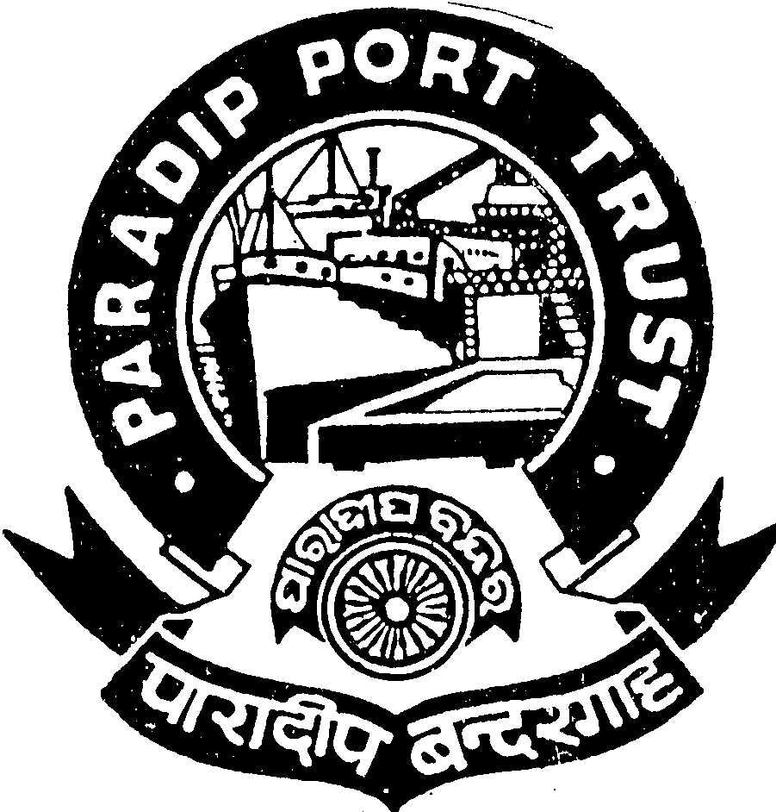
PARADIP PORT TRUST
ADMINISTRATIVE DEPARTMENT
AT/PO: PARADIP PORT,
ODISHA – 754 142

No.AD/RSC-I-21/60/2012/2410 Dated, the 11th June, 2013

Applications are invited from the Indian National for filling up of one post of Senior Welfare Officer (Class-I) as per the terms & conditions given below:

Sr. Welfare Officer(Class-I)

Scale of Pay :-Rs. 20600-46500/- (Pre-revised scale of pay of Rs. 10750-300-16750/-)

Qualification:

- Degree from a recognized University.
- Degree or Diploma in Social Science from a recognized University/Institution.
- 05 years experience as a Labour Welfare Officer/Industrial Relations Officer in an Industrial/Commercial/Govt. Undertaking.
- Knowledge of local language.

Age : Not exceeding 35 years as on 01.05.2013 (Age relaxable as per Govt. rule).

Pay:

Initial Basic pay (ii) IDA 75.4% of the Basic Pay as on 01.05.2013, which is quarterly revised as per Consumer Price Index and Cafeteria @46% of the basic pay. The total emoluments will be Rs. 45608/-.

Other benefits:
Leave Encashment, Leave Travel Concession, Free Medical Treatment for self & family, CPF, etc.

Accommodation: Unfurnished accommodation will be provided as per entitlement.

Pension:
The contributory pension scheme is applicable.

Other Facilities:

Educational facilities up-to Graduation in Science & Arts stream in College situated in the Port Township are available including Central School, English & Oriya Medium School.

Application duly signed giving name, date of birth, permanent and present address, religion, caste, qualification starting from HSC with percentage of mark secured, caste certificate in the prescribed format from the competent authority and work experience with copies of all certificates along-with two pass-port size photographs should reach the Secretary, Paradip Port Trust, At/Po: Paradip Port, Odisha, Pin : 754 142 latest by 10.07.2013 . Persons in the employment of Government/Semi-Government/PSU and autonomous body must apply through proper channel or produce a “No Objection Certificate” from the employer at the time of interview. The application should be type written. Incomplete or late application will summarily be rejected.

Admissible TA (to & fro) in 2nd Class Rail/ Bus in shortest route will be reimbursed to SC/ST candidates subject to production of ticket on the date of interview.

S/d-
Secretary(I/C),
Paradip Port Trust

