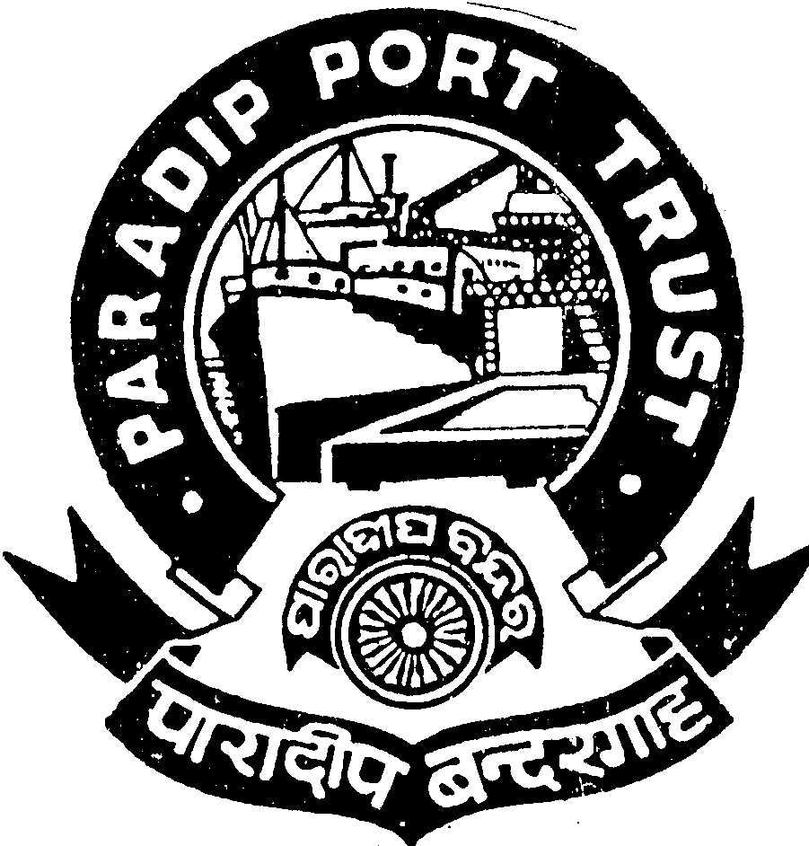
PARADIP PORT TRUST
ADMINISTRATIVE DEPARTMENT
AT/PO: PARADIP PORT,
ODISHA – 754 142

ADVERTISEMENT
No.AD/RSC-I-21/79/2012/2236 Dated, the 29th May, 2013

Paradip Port Trust, ISO-9001: 2008 a certified organization invites application from the Indian National for filling up of one post of Deputy Director (Research) (Class-I) as per the terms & conditions given below:

Deputy Director (Research):

Scale of Pay :-Rs. 20600-46500/- (Pre-revised scale of pay of Rs. 10750-300-16750/-)

Qualification:

- Degree in Economics or Statistics or Mathematics from a recognized University/Institution.
(ii) Five years executive experience in planning or in collection, compilation and interpretation of data or in conducting field surveys, investigations etc.
Desirable :

- Post Graduate degree/diploma in Economics or Statistics or Mathematics or Operational Research and allied subjects from a recognized University/Institution.
- Knowledge of computer operations.

Age : Not exceeding 35 years as on 01.05.2013 (Age relaxable incase of category of SC, ST & OBC
candidates).

Pay:

Initial Basic pay (ii) IDA 75.4% of the Basic Pay as on 01.05.2013, which is quarterly revised as per Consumer Price Index and Cafeteria @ 46% of the basic pay.(The total emolument will be Rs. 45608/-)

Other benefits:
Leave Encashment, Leave Travel Concession, Free Medical Treatment for self & family, CPF etc.

Pension:
The contributory pension scheme is applicable.

Accommodation:-

A ‘C’ Type quarter will be provided on concessional rate.

Other Facilities:

Educational facilities up-to Graduation in Science & Arts stream in College situated in the Port Township are available including Central School, English & Oriya Medium School.

Application duly signed giving name, date of birth, permanent and present address, religion, caste, qualification starting from HSC with percentage of mark secured, caste certificate in the prescribed format and work experience with copies of all certificates along-with two pass-port size photographs should reach the Secretary, Paradip Port Trust, At/Po: Paradip Port, Dist- Jagatsinghpur, Odisha, Pin : 754 142 latest by 25.06.2013 . Persons in the employment of Government/Semi-Government/PSU and Autonomous body must apply through proper channel or produce a “No Objection Certificate” from the employer at the time of interview. The application should be type written. Incomplete or late application will summarily be rejected.

Admissible TA (to & fro) in 2nd Class Rail/ Bus in shortest route will be reimbursed to SC/ST candidates subject to production of ticket on the date of interview.

S/d-
Secretary(I/C),
Paradip Port Trust

