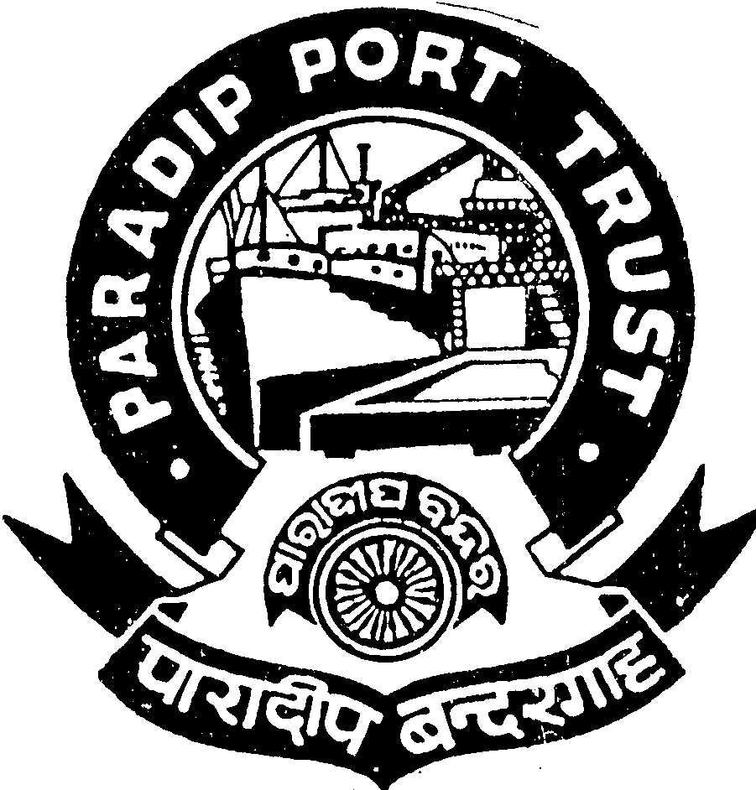

PARADIP PORT TRUST
ADMINISTRATIVE DEPARTMENT
AT/PO: PARADIP PORT,
ORISSA – 754 142

No.AD/RSC-I-21/16/2011(Pt.)/1665 Dated, the 23rd April, 2013

ADVERTISEMENT

Applications are invited from Indian National for filling up of the back-log vacancy of one Post of Pilot, reserved for ST, in the scale of pay of Rs.32900-58000/- as per the terms & conditions given below:

Essential:
(i) Must be holding a certificate of competency as Master of Foreign Going Ship issued by the Ministry of Shipping, Government of India or an equivalent qualification recognized by the Ministry of Shipping, Government of India.
(ii)One year post qualification experience as Master/ Chief Officer of a foreign going ship.

Age as on 01.04.2013 40 years (05 years relaxable for ST candidates)

Pay:
Initial Basic pay + IDA 75.4% of the Basic Pay as on 01.04.2013, which is quarterly revised as per Consumer Price Index along-with Marine allowance and/or cafeteria allowance as admissible. [Marine allowances include Actonnage, Length, Cold Move, Night Pilotage etc and Cafeteria – 46% of the Basic Pay].

Other benefits:
Leave Encashment, Leave Travel Concession, Free Medical Treatment for self & family, CPF, etc.

Pension:
The contributory pension scheme is applicable.

Other Facilities:
Educational facilities for children up-to Graduation in Science & Arts stream in College situated in the Port Township are available including Central School, English & Oriya Medium School.

Application duly signed giving name, date of birth, permanent and present address, religion, caste, qualification starting from HSC with percentage of mark secured, caste certificate in the prescribed format and work experience with copies of all certificates along-with two pass-port size photographs should reach the Secretary, Paradip Port Trust, At/Po: Paradip Port, Orissa, Pin : 754 142 latest by 28.05.2013 Persons in the employment of Government/Semi-Government/PSU and autonomous body must apply through proper channel or produce a No Objection Certificate from the employer at the time of interview. The application should be type written. Incomplete or late application will summarily be rejected.

Admissible TA (to & fro) in 2nd Class Rail/ Bus in shortest route will be reimbursed to ST candidates subject to production of ticket on the date of interview.

S/d-
Secretary(I/C),
Paradip Port Trust

