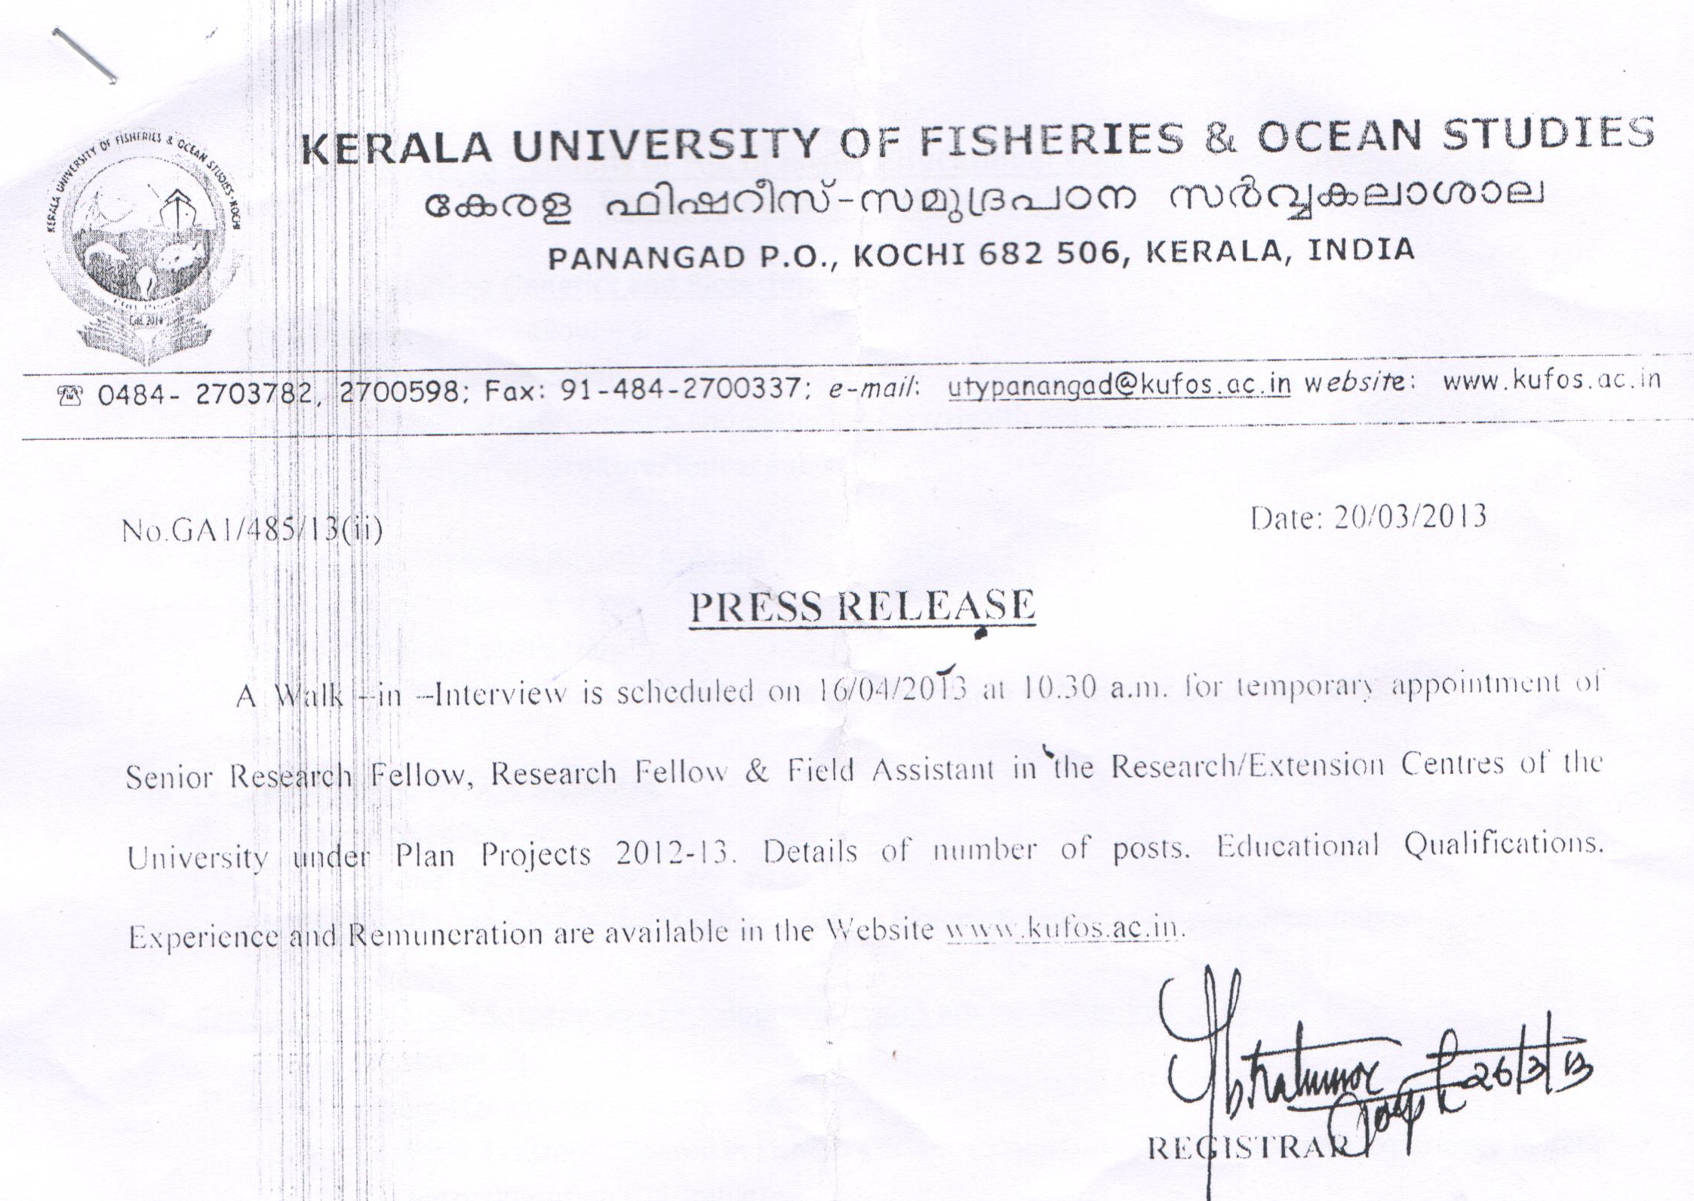
Annual Plan 2012-13 - Details of No. of posts, Educational Qualification, Experience and Remuneration at various Centres
- Centre for Aquaculture Genetics and Biotechnology
- Senior Research Fellow – 1
- Educational Qualification:
MFSc. (Aquaculture/Genetics and Biotechnology/Health Management/Similar subjects)/MSc. Biotechnology/Aquaculture/Similar subjects

- Centre for Taxonomy and Aquatic Animals
- Research Fellow – 1
- Educational Qualification:
MFSc./MSc.Marine Biology/Zoology/Aquatic Biology & Fisheries or equivalent degree

- Centre for Inland Fishery Database
- Research Fellow -4
- Educational Qualifications :
M.FSc/MSc Marine Biology/Zoology/Aquatic Biology & Fisheries or equivalent degree

- Centre for Livelihood Security and Development Issues among Fisher folk of Kerala
- Field Assistant : 2
- Educational Qualification & Experience
- Field Assistant : Degree in Fisheries Science/Commerce/Economics with experience in data entry operation (Desirable)

- Centre for Survey and Appraisal of Socio- economic Status of the Fisher folk
- Research Fellow -1
- Educational Qualification & Experience:
- Research Fellow: PG Degree in Fisheries Science/Commerce / Economics / MSW with experience in data entry operation. Desirable PGDCA

- Centre for Indigenous Knowledge of Traditional Fisher folk – Looping Traditional Knowledge & Science
- Research Fellow -1, Field Assistant -1
- Educational Qualification & Experience:
- Research Fellow: PG Degree in Fisheries Science/Commerce/Economics / MSW with experience in data entry operation. Desirable PGDCA
- Field Assistant : Degree in Fisheries Science / Commerce/Economics/ Statistics/ Sociology with experience in data entry operation (desirable)
Remuneration
Senior Research Fellow/Research Fellow/ Technical Assistant – Rs. 10,000 per month
Field Assistant – Rs. 7500 per month

