
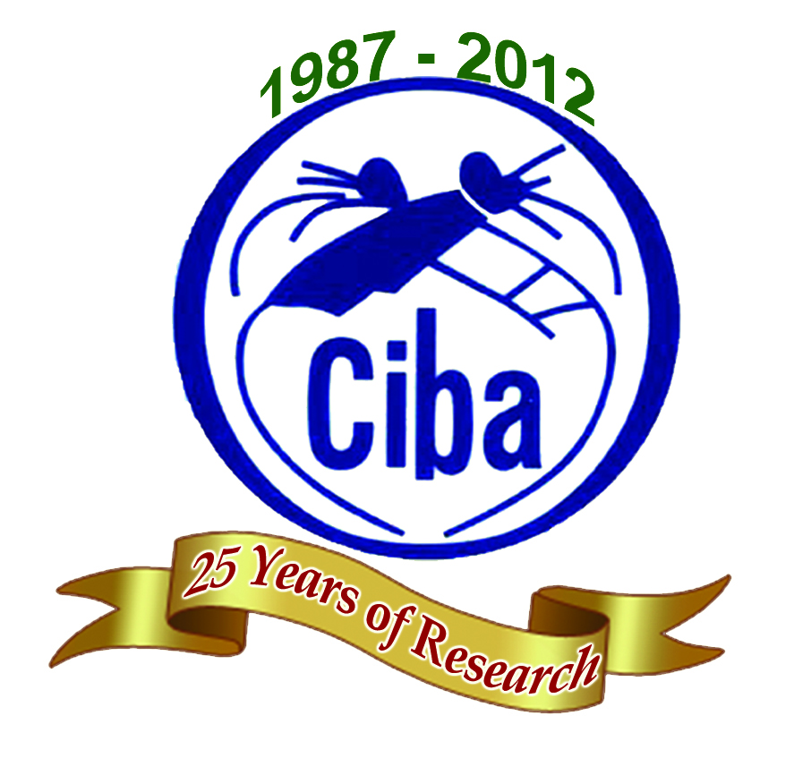
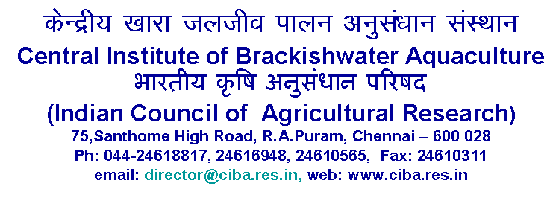

WALK–IN–INTERVIEW

The following posts are to be filled purely on temporary basis under the Indian Council of Social Science Research (ICSSR), New Delhi funded project of this Institute.

Post | Research Investigators – Two posts
Date & Time of Interview | Friday, 15th February 2013 at 10.30 a.m.
Project Name | Assessment on the Impact of Environmental Changes on the Livelihoods of Coastal Women in TamilNadu
Duration | Two years upto 7th June 2014
Essential  Qualification | M.Sc. & above degree in Home Science / Women Studies / Sociology / Social Work / Extension / Life Sciences  (Candidate with experience in typing and computer data entry work will be preferred)  M.Sc. & above degree in Computer Science  (Candidate with good knowledge in data base, excel & analysis work will be preferred)
Nature of Work | Field and survey work at coastal areas in Tamil Nadu.  Research and project documentation work
Emoluments | Rs.10,000/- p.m. (consolidated)
Age Limit | Maximum 35 years for men and 40 years for women as on date of interview. Age limits are relaxable for SC / ST / OBC candidates as per rules.

Eligible Candidates may appear for the Walk-in-interview with original Master’s Degree Certificate, passport size photograph and bio-data enclosing attested copies of educational qualification & experience certificates. TA / DA will not be paid for attending the interview.

PROJECT DIRECTOR

