
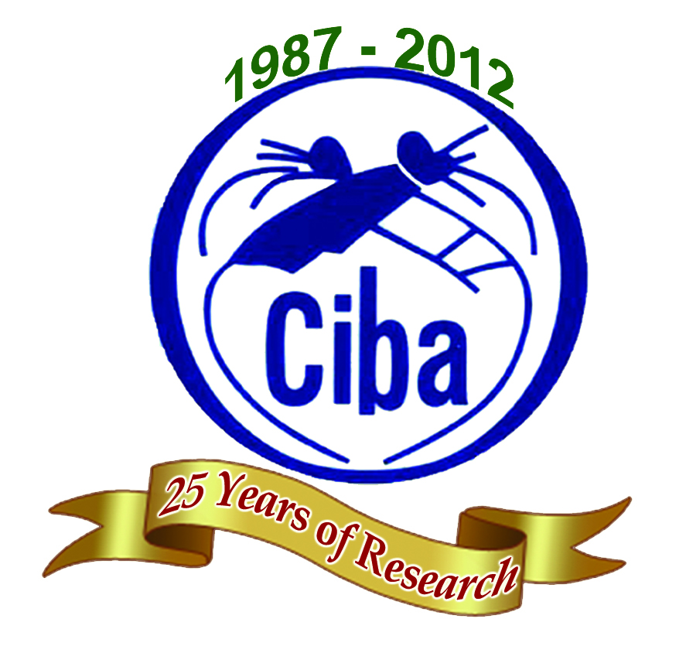
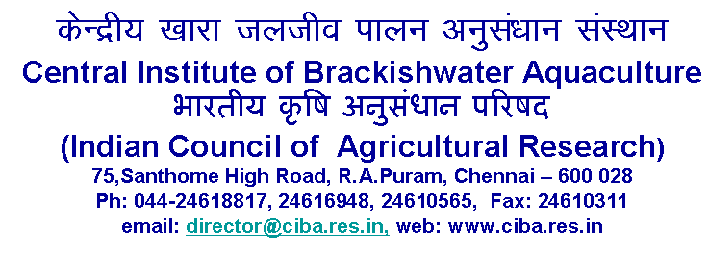

WALK – IN – INTERVIEW

The following post is to be filled purely on contract basis under Indian Council of Agricultural Research (ICAR) funded scheme of this Institute.

Post | Research Associate – One post
Date / Time & Place of Interview | Wednesday, 20th February 2013 at 10.30 a.m.  Conference Hall (II Floor)
Scheme  Name | Intellectual Property Management and Transfer / Commercialization of Agricultural Technology Scheme [Up-scaling of existing components i.e. Intellectual Property Right (IPR)]
Duration | Upto 31.03.2013 / co-terminus with the project
Essential  Qualification | Ph.D. Degree in Biotechnology / Microbiology or M.Sc. Degree in Biotechnology / Microbiology with 1st division or 60% marks or equivalent overall grade point average with atleast two years of research experience in relevant area  Experience and knowledge in Intellection Property Rights & Management is desirable.
Emoluments | Rs.24,000/- + HRA @ 30% p.m. for Ph.D. holders / Rs.23,000/- + HRA @ 30% p.m. for Master Degree holders.
Age Limit | Maximum 40 years for male and 45 years for female candidates as on date of interview. Age limits are relaxable for SC / ST / OBC candidates as per rules.

Eligible Candidates may appear for the Walk-in-interview with original Ph.D. / Master’s Degree Certificate, passport size photograph and bio-data enclosing attested copies of educational qualification & experience certificates. TA / DA will not be paid for attending the interview.

OFFICER INCHARGE - ITMU

